Clinical observation of family benign pancreatic hyperenzymemia
Y. Y. Gubskaya¹, N. B. Gubergrits², A. Ye. Klochkov², T. S. Alianova¹,
P. G. Fomenko²
¹National Medical University n. a. A. A. Bogomolets (Kiev),
²Donetsk National Medical University (Lyman)

Key words: hyperenzymemia, causes, diagnostics, examination algorithm, Gullo’s syndrome
Introduction
Expansion of laboratory diagnostics capability has led to the fact that the recent general practitioner — family medicine physicians and gastroenterologists increasingly deal with cases of asymptomatic elevation of serum amylase, pancreatic isoamylase, lipase and trypsin (alone or in combination). In these clinical situations in front of the doctor sharply raises the question of whether to consider a pancreatic hyperenzymemia biochemical marker subclinical about for some disease or the other way around — a benign condition that does not require correction [1, 5, 16, 20]. Such changes in the concentration of pancreatic enzymes in the absence of active complaints — important clinical findings for further thorough examination of patients.
It is clear that the increase in pancreatic enzymes most commonly associated with the pathology of the digestive system — the very disease of the pancreas, bile ducts, liver, duodenum, celiac disease Whip paragraph la. Several less similar laboratory abnormalities are detected in lesions of the salivary glands, renal failure, malignancies of lung, kidney, thyroid, HIV / AIDS, etc. [1, 2, 3].
A variety of reasons and hyperamylasemia giperlipazemii associated with their products not only acinar cells of the pancreas, but also in other tissues. Thus, isolated blood amylase isoenzyme 2: pancreatic (P-isoamylase) and salivary (S-isoamylase). Improving the performance of amylase in biological Fluid possible with a wide range of disorders: pancreatitis, mumps to ectopic pregnancy and pheochromocytoma [17].
Lipase is synthesized in the pancreas, stomach, intestines, brain; ee activity detected in the saliva. [17]
The causes of an increase in the parameters of amylase and lipase are shown in Fig. 1 and 2.
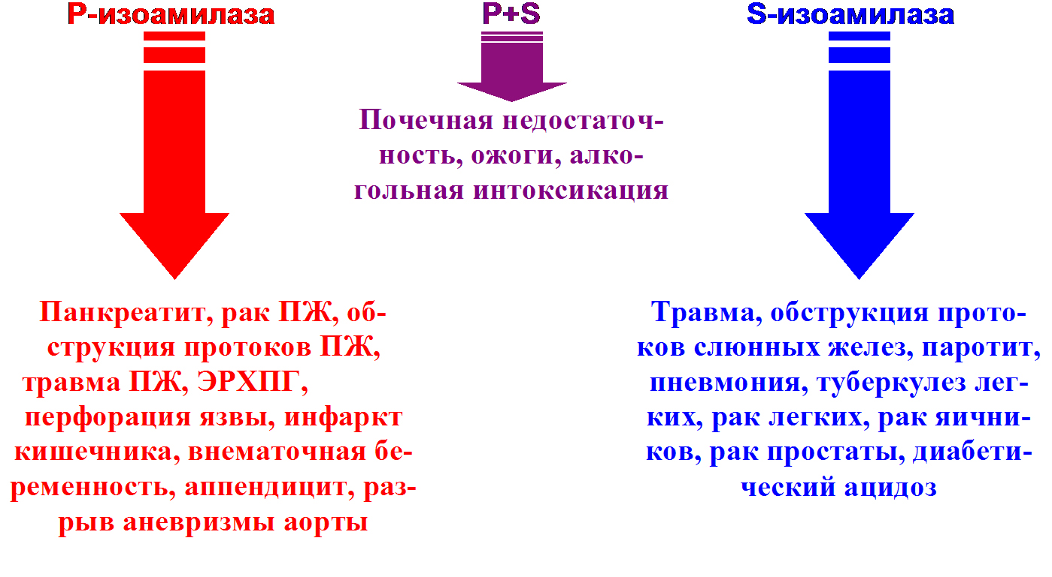

Fig. 1. Diagnostic value of alpha-amylase isozymes upon various diseases [17].

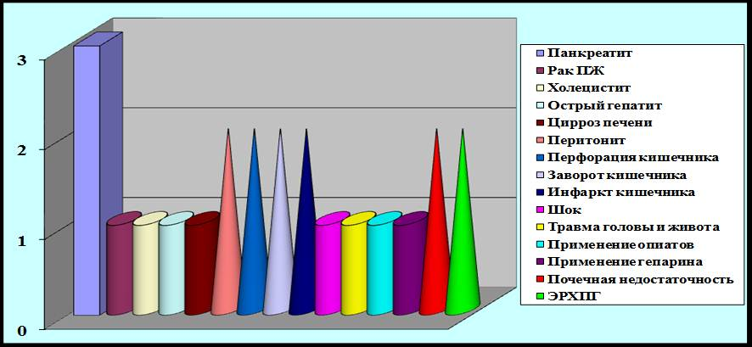
Fig. 2. Activity blood lipase upon various diseases [17].
1 — the norm, 2 — two norms, 3 — three norms.

Trypsin is pancreatic specific enzyme, ie. it is produced only by acinar pancreatic tissue. Recently, however, pancreatic specificity trypsin is being questioned, as to change its parameters is possible with the pathologists of bile tract, chronic renal failure, hypercorticoidism. We can also assume that the CRF broken up with elimination of the enzyme storage f m in the blood, and at about hypercorticoidism proceeds excessive stimulation of pancreatic secretion [17].
However, sometimes an increase in the activity of pancreatic enzymes is asymptomatic. In these cases, the search for the cause of hyperenzymemia is extremely complicated. Diagnosis and differential diagnosis requiring th t a large number of surveys and follow-up. This issue is discussed at almost every meeting of the European Pancreatic Club. Thus, at a meeting of the Club (2008, Poland) is the clinical value of a moderate increase in amylase and lipase blood of unknown etiology few works have been devoted by P. Dite et al. (Czech Republic) A careful examination of 40 patients with moderate hyperamylasemia (figure was increased by no more than 3 times), which lasted more than a year, in 11 cases diagnosed with pancreatic pathology. In particular, during endoscopic retrograde cholangiopancreatography (ERCP) changes in prostate ductal system were detected in 3 patients, but using parenchymal changes endosonography structure — in 5 patients. Thus, 8 patients were diagnosed with chronic pancreatitis (CP). One patient had an autoimmune CP, the other — found mutation of CFTR (cystic fibrosis gene), t. e. pancreatitis was hereditary. In 1 patient diagnosed with benign papillostenoz, from 1 — pancreas divisum, from 1 — makroamilazemiya. In 62.5% of cases was increased activity of P — isoamylase blood. The authors concluded that the need for studies of isoenzymes of amylase in the blood when hyperamylasemia unclear, as the increase in pancreatic isoenzyme in most cases refers to the prostate pathology. In addition, when an obscure and long hyperamylasemia necessary to carry out both ERCP and endosonography. At the same meeting of the Club was presented one more work, devoted to econstant prices long hyperenzymemia unclear. L. Czako et al. (Hungary) more than six months was observed in 5 patients with severe hyperamylasemia and hyperlipasemia (more than 5 standards). In any case, the diagnosis is made was not, however, during the observation period no evident manifestations of the disease or complications develop. Patients were treated with proton pump inhibitors (PPIs), eradication means, but no effect on blood indices had no enzyme treatment. The authors believe that one should keep in mind the possibility of prolonged asymptomatic pancreatic hyperenzymemia, which does not pose a health hazard. Such patients are subject only to observe but not treatment [10].
For the first time a series of cases of persistent asymptomatic hyperenzymemia in healthy persons has been described by the Italian internist researcher Lucio Gullo in 1996. He coined the term "benign pancreatic hyperenzymemia" [1, 12]. Until now, all over the world about 240 cases of Gull syndrome [14] has been fixed. Further research will enable you to divide the family of pancreatic hyperenzymemia, which occurs in the 4, 0 to 19.5% of all cases of asymptomatic benign prostatic enzymes enhancing activity [13, 18]. Gullo syndrome may be associated with Gilbert's syndrome, asymptomatic increase in creatine kinase, transaminase [1, 12].
R. Pezzilli et al. (2009) [7] demonstrated that asymptomatic chronic pancreatic hyperenzymemia only half the time is truly benign, ie. it does not have a detectable morphological substrate. They detail examined 75 patients aged 19 to 78 years who have at least six months were detected asymptomatic increase in the activity of one or more pancreatic enzymes (exclusion criteria were the presence of renal failure, and celiac disease). Survey plan include (one or several studies): multislice computed tomography of the abdominal cavity with contrast enhancement (44 patients), magnetic resonance cholangiopancreatography (MRCP) (50 patients), endoscopic ultrasonography (16 patients).Laboratory examinations included clinical blood analysis, determination of transaminases, gamma glutamyl transpeptidase (GGT), bilirubin, alkaline phosphatase (ALP), total protein, albumin, globulin, cholesterol, triglycerides, calcium, CA 19-9, and a study on makroamilazemiyu method of selective precipitation. CP diagnosed in 20 (26.7%) patients, 5 (6, 7%) patients had intraductal papillary mucinous tumors at 3 — ductal adenocarcinoma of the pancreas, in 2 — Crohn's disease, y 4 — chronic viral hepatitis, y 3 — macroamilasemia, y 1 — autoimmune pancreatitis, 2 cases — serous cystadenoma. Only in 4 cases revealed hyperenzymemia family and in 31 (41.3%) case — chronic non-pathological hyperenzymemia. The authors concluded that the tactics of "watch and wait" chronic asymptomatic pancreatic giperfermentemii unacceptable, careful diagnosticsearch to identify the reasons, which can be detected in most of these patients [7].
Benign pancreatic hyperenzymemia is a diagnosis of exclusion and requires a doctor's in-depth search for other possible causes of asymptomatic increase the activity ofpancreatic enzymes in biological fluids.
Currently, there is no conventional algorithm examination of persons with established elevation of serum amylase, pancreatic isoamylase, lipase and trypsin (alone or in combinations) if they have no organic disease symptoms. However, given the literature, AL Krasnovsky and co-authors. (2014) algorithm survey of these patients (Fig. 3) has been proposed [1]. Preference is given to screening non-invasive laboratory and instrumental tests, which allow to eliminate the most common causes of increasing the activity of pancreatic enzymes. It is especially necessary to screen for possible oncological pathology.

Fig. 3. The diagnostic algorithm for asymptomatic pancreatic hyperenzymemia (according to AL. Krasnovskiy et al., 2014 [1]).

Compliance with this algorithm helps identify organic pathology that is manifested by increased activity asymptomatic pancreatic enzymes and eliminate Gullo syndrome (Table. 1).
Table 1
The results of examination of patients with asymptomatic increase in the activity of pancreatic enzymes in biological fluids and suspected that they have the syndrome of the Gullo (by AL. Krasnovskiy et al., 2014 [1])
Author, year | Amount of observed persons | Detection of organic pathology | Confirmation of Gullo syndrome | Statement of family pancreatic hyperenzymemia
L. Gullo et al., 2009 [15] | 63 | 6 (9.5%) | 57 (90.5%) | Not conducted
R. Pezzilli et al., 200 9 [7] | 75 | 38 (50.7%) | 37 (49.3%) | 3 (8 1%)
A. Mariani, 2010[16] | 75 | 37 (49.3%) | 38 (50.7%) | 2 (5.3%)
A. Amodio et al., 2012 [20] | 160 | 80 (50% 0) | 80 (50% 0) | 26 (32 5%)
M. Di Leo et al., 2013 [11] | 55 | 23 (41.8%) | 32 (58.2%) | Not conducted

Thus, a thorough examination of patients allows them to determine the presence of organic pathology and, accordingly, to treat them effectively. The results also show a low incidence of the syndrome in the population Gullo.
Given the rarity of this condition, even a description of ordinary and clinical cases of pancreatic hyperenzymemia family represents a significant scientific and practical value. In Ukraine, such cases have not been described before.
Clinical case
In January 2016 the doctor-gastroenterologist asked 40-year-old patient K. complained of a burning sensation, tastes sour and bitter in the mouth, heaviness in the epigastrium after eating, nausea at periodic, sharp general weakness.
From the history of the disease is known, that during the period from 2013 g of disease. 3 failed attempts eradication was performed Helicobacter pylori (H. pylori). At the time of treatment the patient has taken dekslansoprazol, famotidine, domperidone, mebeverine, UDCA preparations and valerian in connection with the treatment of functional dyspepsia (H. pylori-associated), biliary dyspepsia.
Anamnesis of life without features. Allergic anamnesis is not burdened. The collection of a family history allowed to reveal that the father of the patient suffers from a peptic ulcer of the bulb of the duodenum.
Objective state at the time of treatment. Skin and visible mucous membranes of normal color, clean. Language is pure. Abdominal palpation surface is soft, painless.Segments of the colon of ordinary properties. Liver at the edge of the costal arch, is painless.
Other organs and systems — without special features.
Set a preliminary diagnosis: functional dyspepsia, H. pylori-associated (after state 3 unsuccessful eradication of H. pylori infection). Biliary dyspepsia.
Later, however, on histological examination of the gastric mucosa and duodenal H. pylori have been identified (see. below).
Against the background of the prescribed treatment in accordance with the established diagnosis (probiotics, enveloping agents, antispasmodics) the general condition is with positive dynamics, satisfactory with a repeated planned examination.
With evaluation results designated analyzes revealed increased activity of alpha-amylase blood to 156.1 U/L (N — up to 100 U/L), although other laboratory parameters — complete blood count with leukocyte formula, ALT, AST, bilirubin, GGT , blood glucose — did not differ from the norms.
Taking into account the revealed laboratory changes, an additional examination of the patient was started in order to exclude organic pathology from her.
According to the recommended algorithm survey of asymptomatic patients with pancreatic hyperenzymemia (Fig. 3) [1] was performed abdominal ultrasonography, repeated blood count, determination of urea, creatinine, alkaline phosphatase, re — GGT, bilirubin and fractions, lipid profile. There were no pathological results. Markers of hepatitis B and C (HBsAg and anti-HCV) were negative oncomarker s (CA 19-9, CEA) — within the normal range. It was also possible presence of the pathology of thyroid (thyroid ultrasound, T _{3,} T _{4,} TSH).
Assessing the results of examinations, it was found raising chromogranin A to 157 ng/ml at the reference values of the index 27,0-94,0 ng / ml. Chromogranin A isoncomarker. However, its increase can also be caused by other factors, such as inflammatory bowel diseases (ulcerative colitis, Crohn's disease) [9, 19], kidney failure, intake of some IPP and Н₂-histamine receptors blockers [6, 8]. Given that the patient continued taking five dekslansoprazol and famotidine were encouraged to re-perform the analysis to determine the content of chromogranin A after 4 weeks after withdrawal of these drugs. This recommendation has been performed and the result is re-analysis was indistinguishable from the normal — 36.1 ng/ml.
The level of enzymes of the prostate was determined repeatedly. Indicators were steadily elevated (see. Table. 2) despite the absence of any complaints.
Tables 2
The results of determining the activity of the patient I pancreatic enzymes K. dynamics
Index | 02/15/2016 | 05/09/2016 | 11/17/2016 | September 1.11.2016
Alpha-amylase (serum), U/L  (N — up to 100 U/L) | 156.1 | 197.0 | 155.8 | 137.3
Alpha-amylase (urine), U/L (N — up to 447 U/L) | Not determined | Not determined | 842.2 | 1043.5
P-isoamylase, U/L  (N — 13–53 U/L) | Not determined | Not determined | 98 | Not determined
Lipase, U/L  (N — 13,0–60,0 U/L) | Not determined | Not determined | 149 | Not determined

During the observation period the level of pancreatic enzymes did not decrease to normal index x s, which is clearly seen in the analysis of the serum alpha-amylase of patient K (Fig. 4.).
Fig. 4. The results of measurements of alpha-amylase serum in patient K in dynamics for 2016 (U/L).

CT scans were performed abdominal cavity and retroperitoneal space with double contrast (no pathology) endosonography of the pancreas (Fig. 5).
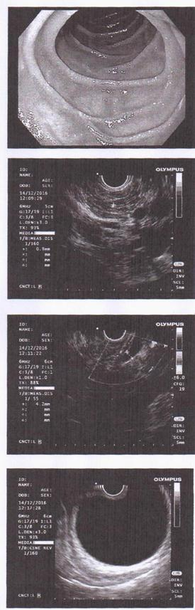
Fig. 5. Results endosonography of the pancreas of patient K.

Conclusion of the endosonography pancreas and bile ducts of the patient K. performed using a video endoscope Olympus EXERA III 190 under general anesthesia: the pancreas is not increased, contours precise, echogenicity in all departments uneven, without focal lesions; Wirsung’s duct is not expanded in all departments, and the wall is, of not thickened and not of vita; distal choledochus diameter of 4 mm, its wall is not thickened; a gallbladder without inclusions in the lumen, its walls are not changed; in the surrounding tissue of enlarged lymph nodes are not visualized.
Mucosa biopsies of the antrum, the angle of the body and the stomach duodenum. Analysis of biopsies allowed helikobakterioz exclude organic pathology in gastroduodenal zone.
Repeated ultrasound of the abdomen and histological examination of duodenal biopsies performed at the Department of Gastroenterology and Hepatology, University Hospital Zurich (Klinikum Bayreuth Gmbl — Institut fur Pathologie) (Fig. 6). At the same diseases s Whipple, celiac disease and pancreatic pathology is not detected. Giardiasis has also been excluded.
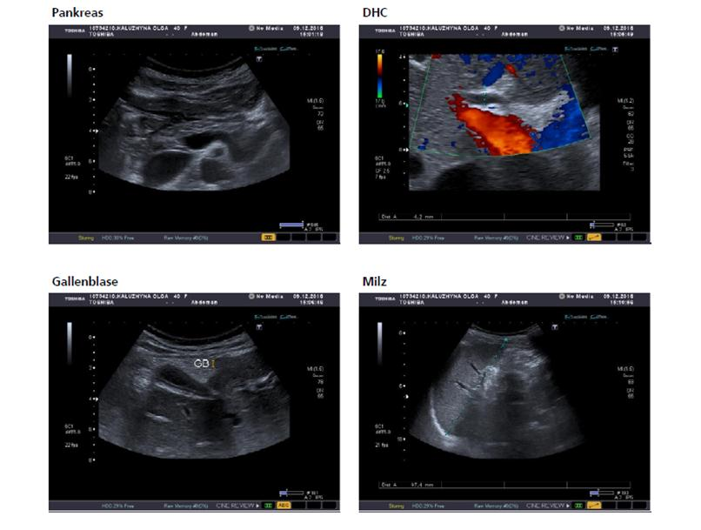
Fig. 6. Ultrasound of the abdominal organs of patient K.

Thus, given the existence of asymptomatic pancreatic giperfermentemii K. patients for 1 year in the absence of evidence to support the organic lesions of the pancreas or other diseases with similar laboratory manifestations, one can argue about the case of an establishment Gullo syndrome.
At the same time, a survey of 10-year-old son MK patient about ARI with intestinal syndrome in January 2016 established a similar (Maternal) asymptomatic pancreatichyperfermentemia [4]. These re-definitions of the patient's pancreatic enzymes M are shown in Table. 3.
Tables 3
The results of determination of the activity of the enzymes of the pancreas of the patient M. in dynamics
Index | 29.01.  2016 | 09.05.  2016 | 31.10.  2016 | 05.11.  2016 | 08.11.2016 | 11.11.2016 | 17.11.2016
Alpha-amylase (serum), U/L  (N — up to 100 U/L) | 204.3 | 242.7 | 129.1 | 163.2 | 131.5 | 167.9 | 212.2
P-isoamylase (serum), U/L (N — up to 53 U/L) | Not detected | Not detected | Not detected | Not detected | Not detected | Not detected | 183
Alpha-amylase (urine), U/L (N — up to 491 U/L) | Not detected | Not detected | 804.6 | 2000.0 | 1429.7 | Not detected | 1028.1
Lipase, U/L (N — 13,0–60,0 U/L) | Not detected | Not detected | 204.8 | Not detected | Not detected | Not detected | 277.5
Trypsin, U/L (N — 140–400 U/L) | Not detected | Not detected | >1500 | Not detected | >1500 | Not detected | Not detected

Other results of laboratory tests — a general blood test with leukocyte formula, CRP, blood glucose level, alkaline phosphatase, total protein with its fractions, ANA, ANCA, gliadin IgG, general urine analysis — did not reveal any abnormalities. At US of organs of an abdominal cavity, FEGDS also organic pathology is not found. When examining the level of IgG4 in the serum, normal indices were obtained to exclude autoimmune pancreatitis. Fecal elastase-1 — 720 μg/g (the norm is higher than 200 μg/g).
During the observation period, the activity of the pancreatic enzymes of the M. patient did not decrease to normal values, as is evident from the analysis of serum alpha-amylase activity (Fig. 7) and urine (Fig. 8).
Fig. 7. Results of the determination of serum alpha-amylase in patient M. in dynamics during 2016 (U/L).
Fig. 8. Results of the determination of urine alpha-amylase in patient M. in dynamics during 2016 (U/L).
To exclude the genetic mutation of genes PRSS1, SPINK1 (genetic markers of hereditary pancreatitis) [21], as a cause of stable pancreatic hyperenzymemia, a genetic analysis (sequencing) of these genes was carried out, which did not reveal their pathological variants. According to the conclusion of the laboratory "Human genetische Apparategemeinschaft" (Berlin), by means of sequencing no pathogenic variant was found. Since the large deletions / duplications of these two genes that can not be detected by sequencing have been described, it has been recommended to continue the deletion / duplication study to test their pathological variants. When the study was continued, no major deletions / duplications were found in the genes PRSS1, SPINK1 or the sites that affected them.
In a genetic study, a heterozygous insertion of the dinucleotide TA (A (TA) 7TAA) was found, that is, the patient M. is a heterozygote for Gilbert's syndrome.
In addition, a polymorphism of C / C, characteristic of lactose intolerance in a homozygous form, was revealed (a similar polymorphism was found in the mother — patient K. and in grandfather — the father of the patient K.).
Conclusion Genetics (National Children's Specialized Hospital Okhmatdet, Center for Orphan Diseases): Considering the biochemical phenotype of grandfather, mother and son, presumably it is an autosomal dominant type of inheritance of benign family pancreatic hyperenzymemia. According to the literature, molecular genetic diagnosis is under development.
In addition, parents of patient K. were examined. Her father (76 years old) had a significant increase in the indices of amylase and lipase of blood. In particular, amylase is raised to 1.5 norms, lipase — up to 4 norms (in the absence of significant changes from the pancreas with ultrasound).
The daughter of the patient K. (sister of the patient M.), 14 years old, was also examined. Indicators of pancreatic enzymes in the blood and urine are within normal limits.
During the year of observation of the patient K., her father and son M. still asymptomatic pancreatic hypermentemia remains.
Discussion and conclusions
Given the presence of asymptomatic pancreatic hyperenzymemia in relatives of the first line of kinship for 1 year, the lack of data in favor of organic damage to the pancreas or other pathology with similar laboratory manifestations can be confirmed about the case of the establishment of the Gullo syndrome (familial pancreatic hyperenzymemia).
To finalize the diagnosis in accordance with existing recommendations, it is advisable to observe for 2 years with repeated examination of patients.

References:
- Бессимптомная панкреатическая гиперферментемия / А. Л. Красновский, С. П. Григорьев, И. В. Золкина [и др.] // Российский медицинский журнал. — 2014. — № 5. — С. 52–56.
- Всегда ли гиперамилаземия связана с хроническим панкреатитом? / Д. И. Абдулганиева, А. Х. Одинцова, Н. А. Черемнна, А. Х. Хафнзова [и др.] // Практическая медицина. — 2011. — № 7. — С. 157–159.
- Губергриц Н. Б. Макроамилаземия — безобидное заблуждение или опасное незнание? / Н. Б. Губергриц, Г. М. Лукашевич, Ю. А. Загоренко // Сучасна гастроентерологія. — 2006. — № 6. — С. 93–99.
- Уніфіковані клінічні протоколи медичної допомоги дітям із захворюваннями органів травлення [Електронний ресурс]. — 2013. — Режим доступу до ресурсу: http://www.moz.gov.ua/docfiles/dod59_2_2013.pdf.
- Alianova T. S. Family benign pancreatic hyperenzymemia : a case report / T. S. Alianova, O. Y. Gubska // Scientific discussion. — 2017. — Vol. 4. — P. 4–6.
- Chromogranin A — biological function and clinical utility in neuro endocrine tumor disease / I. M. Modlin, B. I. Gustafsson, S. F. Moss [et al.] // Ann. Surg. Oncol. — 2010. — Vol. 17, No 9. — P. 2427–2443.
- Chronic asymptomatic pancreatic hyperenzymemia is a benign condition in only half of the cases : a prospective study / R. Pezzilli, A. M. Morselli-Labate, R. Casadei [et al.] // Scand. J. Gastroenterol. — 2009. — Vol. 44, No 7. — P. 888–893.
- The clinical relevance of chromogranin A as a biomarker for gastroenteropancreatic neuroendocrine tumors / B. Lawrence, B. I. Gustafsson, M. Kidd [et al.] // Endocrinol. Metab. Clin. North Am. — 2011. — Vol. 40, No 1. — P. 111–134.
- El-Salhy M. Changes in enteroendocrine and immune cells following colitis induction by TNBS in rats / M. El-Salhy, J. G. Hatlebakk / Mol. Med. Rep. — 2016. — Vol. 14, No 6. — P. 4967–4974.
- European Pancreatic Club. Joint Meeting of the European Pancreatic Club (EPC) and the International Association of Pancreatology (IAP) / European Pancreatic Club, International Association of Pancreatology // Pancreatology. — 2008. — Vol. 8, No 3. — P. 285–400.
- EUS and s-MRCP findings in asymptomatic subjects with chronic pancreatic hyperenzymemia / M. Di Leo, R. A. Zuppardo, A. Mariani [et al.] // JOP. — 2013. — Vol. 14, No 5S. — https://doi.org/10.6092/1590-8577/1710.
- Gullo L. Chronic nonpathological hyperamylasemia of pancreatic origin / L. Gullo // Gastroenterology. — 1996. — Vol. 110, No 6. — P. 1905–1908.
- Gullo L. Familial pancreatic hyperenzymemia / L. Gullo // Pancreas. — 2000. — Vol. 20, No 2. — P. 158–160.
- Gullo’s syndrome : a case report / P. Kumar, A. Ghosh, V. Tandon, R. Sahoo // J. Clin. Diagn. Res. — 2016. — Vol. 10, No 2. — P. OD21–OD22.
- Magnetic resonance cholangiopancreatography in asymptomatic pancreatic hyperenzymemia / L. Gullo, L. Lucrezio, L. Calculli [et al.] // Pancreas. — 2009. — Vol. 38. — P. 396–400.
- Mariani A. Chronic asymptomatic pancreatic hyperenzymemia: is it a benign anomaly or a disease / A. Mariani // JOP. — 2010. — Vol. 11, No 2. — P. 95–98.
- The pancreas : an integrated textbook of basic science, medicine and surgery / Eds. : H. G. Beger [et al.]. — Malden [et al.] : Blackwell Publishing, 2008. — 1006 p.
- Pezzilli R. Familial pancreatic hyperenzymemia / R. Pezzilli // Pancreatic Dis. Ther. — 2013. — http://dx.doi.org/10.4172/2165-7092.S1-e001.
- Plasma chromogranin A in patients with inflammatory bowel disease / V. Sciola, S. Massironi, D. Conte [et al.] // Inflamm. Bowel Dis. — 2009. — Vol. 15, No 6. — P. 867–871.
- Prospective evaluation of subjects with chronic asymptomatic pancreatic hyperenzymemia / A. Amodio, R. Manfredi, A. M. Katsotourchi [et al.] // Am. J. Gastroenterol. — 2012. — Vol. 107, No 7. — P. 1089–1095.
- The N34S mutation of SPINK1 (PSTI) is associated with a familial pattern of idiopathic chronic pancreatitis but does not cause the disease / J. Threadgold, W. E. Greenhalf, N. Howes [et al.] // Gut. — 2002. — Vol. 50, No 5. — P. 675–681.

Clinical observation of family benign pancreatic hyperenzymemia
Y. Y. Gubskaya¹, N. B. Gubergrits², A. Ye. Klochkov², T. S. Alianova¹,
P. G. Fomenko²
¹National Medical University n. a. A. A. Bogomolets (Kiev),
²Donetsk National Medical University (Lyman)

Key words: hyperenzymemia, causes, diagnostics, examination algorithm, Gullo’s syndrome
The article provides a brief literature review on the problem of asymptomatic pancreatic hyperenzymemia and an algorithm for examining patients. The authors for the first time in Ukraine have described the clinical observation of family with Gullo’s syndrome — family benign pancreatic hyperenzymemia. Family members were carefully examined, structural changes in the pancreas were excluded, and its normal functional state was proved. The results of a genetic examination are presented.

