Міністерство охорони здоров’я України
Національний медичний університет імені О. О. Богомольця
Кафедра анестезіології та інтенсивної терапії
“Basics of cardiac-pulmonary-cerebral resuscitation”
(методичні рекомендації для студентів іноземних факультетів медичних університетів)

14.01.20
Анестезіологія та інтенсивна терапія

2024

МеТОДИЧНІ РЕКОМЕНДАЦІЇ
УДК 616-083.98-089.5(075.3)

Методичні рекомендації «Основи серцево-легенево-мозкової реанімації» присвячені практичним питанням навчання виконання серцево-легенево-мозкової реанімації. В рекомендаціях розглянуто питання проведення реанімаційних міроприємств на різних стадіях та етапах реанімації.
Методичні рекомендації написані для іноземних студентів медичних університетів.
Methodical recommendations “Basics of cardiac-pulmonary-cerebral resuscitation” are dedicated to practical nutrition in the field of cardiac-legenological-cerebral resuscitation. The recommendations cover nutrition during resuscitation measures at various stages of resuscitation.
Methodical recommendations written for foreign students of medical universities.
Рекомендовано до друку на засіданні кафедри анестезіології та інтенсивної терапії Національного медичного університету імені О. О. Богомольця МОЗ України (протокол № 4 від 18.10.2024)

Установа-розробник: НАЦІОНАЛЬНИЙ МЕДИЧНИЙ УНІВЕРСИТЕТ імені О.О. БОГОМОЛЬЦЯ МОЗ УКРАЇНИ
Укладачі (автори): ОЛІЙНИК ОЛЕКСАНДР ВАЛЕНТИНОВИЧ – професор кафедри анестезіології та інтенсивної терапії НМУ імені О.О.Богомольця, доктор медичних наук, професор
Рецензенти: ЯРОСЛАВСЬКА СВІТЛАНА МИКОЛАЇВНА − завідувач кафедри анестезіології та інтенсивної терапії НМУ імені О.О.Богомольця, канд. медичних наук, доцент;
БАСМАНОВ СЕРГІЙ МИКОЛАЙОВИЧ- доцент кафедри анестезіології та інтенсивної терапії НМУ імені О.О.Богомольця, канд. медичних наук, доцент.

ВASIC CONCEPTS AND DEFINITIONS
Resuscitation - the science of the mechanisms of extinction, methods of management, artificial replacement and restoration of vital functions of the organism, which is in the conditions of aggression of so degree that exceeds the possibilities of autoregulation. The subjects of the study of resuscitation are critical and terminal conditions.
Critical state is an extreme degree of any pathology in which disorders of physiological functions and disorders of individual systems cannot spontaneously be corrected by self-regulation and require partial or complete correction or artificial replacement.
Terminal states - the last stages of life (the boundaries between life and death); preagony, agony, clinical death.
The use of both terms as successive steps, signify the transition from disease pathogenesis to tanatogenesis.
The basic methodological principle of resuscitation is a systematic approach, which follows from the idea of the non-specificity of the syndrome as a clinical phenomenon.
One can completely agree with GA Ryabov's (1999) opinion that the formation of syndromology is the philosophy of critical state medicine, which explains the essence of the disease, makes it possible to find common ground and may suggest rational ways of medical decisions.
Resuscitation (lat. reanimation - recovery) - a complex of therapeutic measures aimed at restoring of vital functions of the body in the case of cardiac and respiration arrest.
Dying - the process of decaying of vital functions of the body; not only the qualitative transition from life to death, but also the consistent and regular disturbances of the body's functions and systems, which result in their shutdown. Even the sequencing and gradual shutdown of functions gives time and makes it possible to intervene to restore life.

The main stages of attenuation of vital functions of the body
Preagonia, terminal pause and agony - the stages of dying by VA Negovsky, now they have more historical significance and are not considered in detail.
Clinical death is a reversible condition, beginning with the cessation of vital functions (circulation, respiration) until the onset of irreversible changes in the cerebral cortex. In other words, it is time when neurons of the cerebral cortex maintain their viability in anoxia (since the content of O₂ in the brain tissue is reduced to zero within 1 min from the moment of cardiac arrest).
The duration of clinical death primarily depends on the temperature of the body: as temperature increases, the period of clinical death is reduced to 1–2 min by increasing the oxygen consumption of tissues due to the prevalence of dissociation of oxyhemoglobin over its production. On the contrary, when temperature lowers (in case of hypothermia), the clinical death lengthens to an average of 12 min by reducing the oxygen consumption of tissues (in exceptional cases, such as drowning in icy water, this period can be 30–60 or more minutes). At normal temperature the period of clinical death is 3–5 min, being a limiting factor in resuscitation.
Thus, on average, when CPR is started within 5 min after cardiac arrest and ends with restoration of spontaneous circulation and respiration, there is a high chance of full mental restoration without neurological deficit. If CPR started within 10 min after cardiac arrest, the recovery of consciousness will be accompanied by neurological disorders of different severity, and if after 15 min, it is possible to restore only the vegetative functions, whereas the recovery of consciousness is impossible (i.e. in most cases there will be a so-called social death, a synonym of vegetative state). CPR started within 20 min or more after cardiac arrest is associated with total loss of all sections of the brain, including the stem structures (decerebration), when it becomes impossible to restore even the vegetative functions.
Social death is a partly reversible condition characterized by irreversible loss of the cerebral cortex function (decortication), while maintaining the vegetative functions.
Biological death is an irreversible state of the cells of vital organs, when the revival of the organism as an integrated system is impossible.
Brain death is a total and irreversible cessation of all the brain functions, while the heart is working, during mechanical ventilation, infusion and drug therapy.
In contemporary understanding, brain death is a juridical equivalent of a person’s death.

Symptoms of clinical death according recommendation of Basic life support
- Absence of respiration. Presence of respiration is evaluated by listening to the movement of air around the person’s airways, and monitoring chest excursion.
- Absence of consciousness.

Symptoms of clinical death according recommendation of Advanced life support
- Absence of pulse on the carotid arteries. Pulse on the carotid arteries is determined with a use of palpation, by slowly shifting the index and middle fingers from the angle of the thyroid cartilage (Adam’s apple) to the inner edge of the sternocleidomastoid muscle
- Absence of respiration. Presence of respiration is evaluated by listening to the movement of air around the person’s airways, and monitoring chest excursion.
- Pupil dilation in the absence of reaction to light (emerges after 1 min after cardiac arrest).
Diagnosis of clinical death must be carried out as quickly as possible (within 10–15 sec) for the immediate start of resuscitation, because if the critical period of 3–5 min of clinical death is overlooked, an irreversible damage to the brain begins.

Indications to cardiopulmonary resuscitation
All cases of clinical death, regardless of its causing factors.
Contraindications to cardiopulmonary resuscitation
All cases when it is known that resuscitation is absolutely useless and hopeless:
1. The onset death due to a long debilitating disease, in which all modern methods of treatment have already been used and death is not a surprise (in this case, resuscitation will not prolong life, but only extend the process of dying that is not humane).
2. The onset death of patients with incurable diseases (oncopathology in the terminal stage, terminal stages of brain circulatory violations – strokes).
3. If there are signs of biological death.
Stages of cardiopulmonary and cerebral resuscitation
The cardio-pulmonary resuscitation algorithm - ABC (A- Airway, B- Breathing, C- Circulation), initiated by P. Safar, since the recommendations of ERC 2010, was modified in the CAB algorithm:
C- artificial maintenance of blood circulation;
A - control and restoration of airway patency;
B- artificial respiration support.
Thus, after diagnostics of a stop of blood circulation it is necessary to bstart chest compression immediately and only after that provide airway patency and hold artificial respiration and cerebral resuscitation. P. Safar divided the whole CPR complex into 3 stages, each with its purpose and steps:
Stage I. Basic life support:
Purpose – emergency oxygenation.
Steps:
C. Artificial maintenance of circulation.
A. Airway examination and management.
B. Artificial maintenance of respiration.
Stage II. Advanced life support:
Purpose – restoration of spontaneous circulation.
Steps:
D. Drug therapy.
E. Electrocardiogram.
F. Defibrillation.
Stage III. Prolonged life support.
Purpose – cerebral resuscitation and postresuscitation intensive care.
Steps:
G. Assessment (establishing the causes of cardiac arrest and its therapy) of the chance to fully rescue the
patient considering the possible degree of central nervous system (CNS) damage.
H. Complete mental restoration.
I. Correction of the disturbed functions of other organs and systems.
«The chain» of survival
American Heart Association (AHA) proposed an algorithm of first aid organization called the chain of survival, which includes (Fig. 4):
1. Early activation of emergency medical services.
2. Early basic life support (steps A–B–C).
3. Early defibrillation with automated external defibrillators (AED).
4. Early beginning of further life support, including intubation and use of drugs.
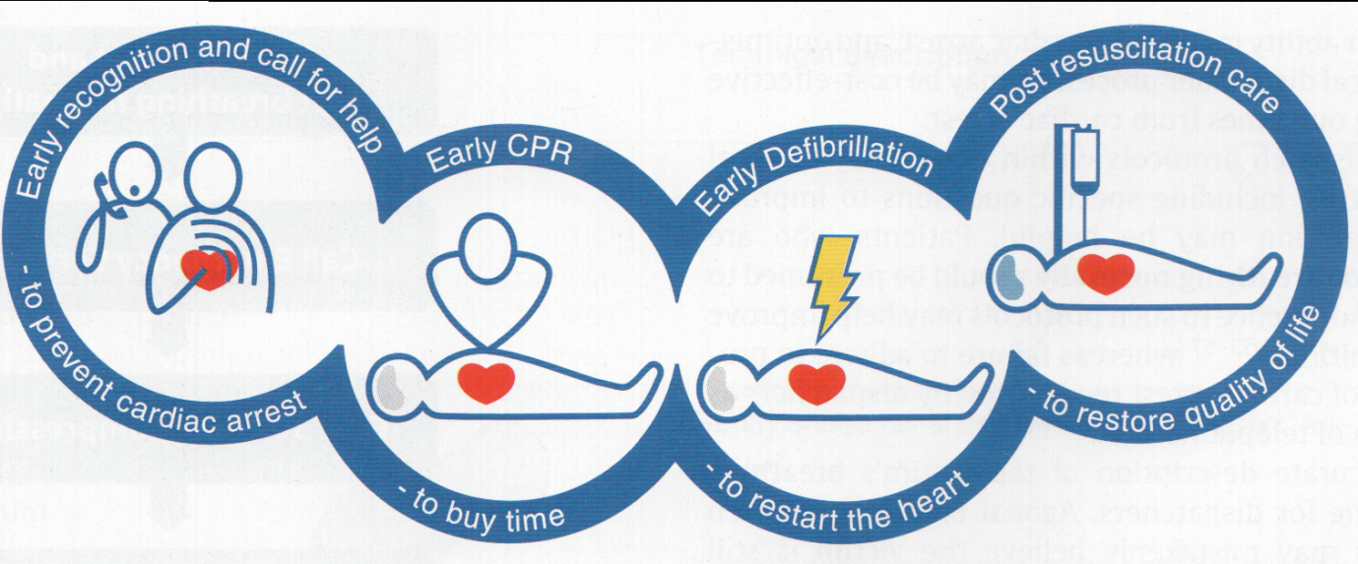
Fig. The chain of survival (ERC’2015)

BASIC LIFE SUPPORT
Step C: Artificial maintenance of circulation
Chest compressions. The fundamental problem of the artificial maintenance of blood circulation is very low (less than 30 % of normal) cardiac output (CO) generated during chest compression. The correctly performed compression maintains the level of systolic blood pressure at 60–80 mm Hg, while diastolic blood pressure rarely exceeds 40 mm Hg, and, consequently, causes a low level of brain (30–60 % of normal) and coronary (5–20 % of normal) blood flow. During chest compressions coronary perfusion pressure increases only gradually and therefore with each pause needed for mouth-to-mouth breathing it is rapidly declining. However, a few extra compressions lead to restoration of the initial level of cerebral and coronary perfusion. In this regard, significant changes have occurred in the algorithm of chest compression.
According to the research the ratio of compressions to the respiratory rate 30:2 is more effective than 15:2, providing the most optimal balance between blood flow and oxygen delivery, and therefore the ratio of compressions and artificial breaths number for one or two rescuers should be 30:2.
Chest compression technique. Then the point of compression should be determined with the next method: using the palpation find the end metasternum and place two transverse fingers. The upper edge of them would be the place where the copressions should be performed. Then place one hand between the middle and lower thirds of the sternum (the fingers along the ribs), and the other hand - on it`s top. The “lock” position of palms may be used. Compressions are carried out with the hands straightened in the elbows, using part of the body weight..

Chest compressions should be carried out with a frequency of 100-120/min (about 2 compressions per sec) at a depth not less than 5 and not more than 6 cm, pausing for artificial respiration (it is not acceptable to conduct air insufflation at the time of chest compressions in unintubated patients – the danger of getting air into the stomach exists).
Modern models of defibrillators have implemented technology to check the quality of chest compression according to the frequency and depth of compression, and the quality of ventilation according to the frequency and volume. This device is placed on the chest of the patient. The parameters of compression and ventilation are displayed on the screen of defibrilator, which has a function of the voice feedback to control the correctness of the resuscitation measures.
Signs of chest compression correctness and effectiveness are the presence of pulse wave on the main and peripheral arteries.
To determine the possible restoration of spontaneous circulation every 2 min of CPR a pause (for 5 sec) is made to check the pulse on the carotid arteries.
For children aged 10–12 years chest compressions are carried out with one hand, and the ratio of compressions and breathing should be 15:2. For neonates and infants – with the tips of two fingers with a frequency of 100–120 rpm.

Step A: Airway management
The main arising problem of the unconscious patients, is obturation of the respiratory tract by the tongue and epiglottis in the laryngopharyngeal area due to the development of muscular atony. Obturation occurs at any position of the patient (even in the prone one), and during the tilt of the head (chin to chest), it occurs in virtually 100 % of cases. So the first thing that must be undertaken is to find out if the person is unconscious – to call out (loudly ask: What happened? Open your eyes!), pat on the cheeks, gently shake the shoulders. Once it’s obvious that the victim is unconscious, it is necessary to manage the airways.
The “gold standard” for airway management is P. Safar’s triple airway maneuver and tracheal intubation.
Triple airway maneuver
P. Safar developed the triple airway maneuver which includes tilting the head, opening of the mouth and thrusting the lower jaw. When this technique is carried out, the tongue is pulled forward, rising above the posterior wall of the pharynx, and the entrance to the trachea opens.
During the manipulations on the respiratory tract one should be aware of possible damage to the cervical spine. The highest probability of injury of the cervical spine may occur in two groups of victims:
1) in car accidents (a person was struck by a car or was in a car during a crash);
2) when falling from a height (including “divers”).
So in such patients you cannot tilt (bend the neck forward) and turn the head to the side. In these cases it is necessary to conduct a mild traction of the head and then, holding the head, neck and chest in the same plane, exclude neck overextension, with minimum tilting of the head and simultaneous opening of the mouth and thrusting of the lower jaw. During first aid the neck-fixing Schantz collar should be used.

Pict. 1. Jaw thrusting forward and up.
- Mouth_to_mouth ventilation (left hand closes nostrils, right hand extends the neck).

Forced opening of the mouth and finger sweep
Head tilt by itself does not guarantee restoration of airways patency. Thus, in 1/3 of unconscious patients due to muscular atony the nasal passages during exhalation are closed by the soft palate moving like a valve. In addition, it may be needed to remove foreign bodies from the oral cavity (blood clots, vomit, fragments of teeth, etc.). Therefore, especially for people with injuries, it is necessary to examine the oral cavity and if necessary, conduct a finger sweep. To open the mouth, one of the following methods is used.
1. The maneuver with crossed fingers is appropriate for a moderately relaxed lower jaw. A resuscitator stands at the head end or one side of the patient’s head. The index finger is placed into the corner of his mouth and the resuscitator presses the victim’s upper teeth, then the thumb is placed opposite to the index finger on the lower teeth (Fig. 5) and the mouth is forced to open. Thus, significant transcending power can be achieved, allowing to open the mouth and examine the oral cavity. If foreign bodies are present, they should be immediately removed. To do this, one must turn the patient’s head to the right, without altering the position of the fingers of his left hand. The right index finger pulls the right corner of the mouth down, making it easier to drainage the oral cavity of the liquid contents. With one or two fingers, wrapped with a handkerchief or other cloth, clean the mouth and pharynx.
2. Lifting the tongue and jaw maneuver. In the case of a fully relaxed jaw the left thumb is put in the victim’s mouth and the fingertip lifts the tongue root. Other fingers grasp the lower jaw on the chin and thrust it forward.
In order to restore airway patency, I-gel laryngeal mask, which has a cuff made in the form of a larynx from a thermoplastic elastomer gel, is widely used, which ensures reliable airway sealing. Installing this laryngeal mask requires minimal use of skills that are easy to master during medical training. The size of the laryngeal mask is selected depending on the weight of the patient.
Stable position on the side
If the victim is unconscious, but has a pulse and maintains adequate spontaneous respiration, it is necessary to give a stable position on the side to prevent aspiration of gastric contents due to vomiting or regurgitation and to manage the airway. To do this, bend the person’s leg on the side of rescuer, put the victim’s hand under his buttock on the same side. Then carefully turn the victim on the same side, simultaneously tilt the head and keep the victim’s face down. Put the victim’s upper hand under the cheek to keep the head position and to avoid the face turning down. In this case the victim’s hand behind the back would not allow him to take a supine position.
Algorithm of help during obstruction of the respiratory tract by a foreign body
In case of partial airway obstruction (maintaining normal color of the skin, patient’s ability to speak and effectiveness of cough), immediate intervention is not indicated.
In case of complete airway obstruction (if the patient is unable to speak, cough is ineffective, there is an increasing difficulty in breathing, cyanosis) the following assistance is recommended, depending on whether the patient is conscious or not:
a). conscious – 5 hand back blows between the shoulder blades or 5 abdominal thrusts – Heimlich maneuver. To do the last - the rescuer stands behind the victim, clenches his hand into a fist and puts (the thumb side) to the victim’s abdomen on the midline between the umbilicus and xiphoid process. Firmly grasping the fist by the other hand, presses his fist in the victim’s abdomen quickly in the upward direction. It can’t be performed in pregnant and obese individuals, and is replaced with chest compression.
b). unconscious – the beginning of CPR complex:
- open the mouth and try to remove a foreign body with the fingers;
- diagnose the absence of spontaneous breathing (look, listen, feel);
- immediately begin chest compressions to eliminate airway obstruction (as it creates a higher pressure in the respiratory tract, helps to remove the foreign body, then the back blows and abdominal thrusts that are not recommended in unconscious patients).
- after 30 compressions, open the victim’s mouth and try to remove the foreign body, perform two breaths.
- assess the effectiveness: if there is an effect, determine the presence of signs of spontaneous circulation, and if necessary, continue chest compressions and/or artificial respiration; if there is no effect, repeat the cycle – paragraphs 3–4 times.
Step B: Artificial maintenance of respiration
After circulation arrest and during ongoing CPR a decrease in lung compliance occurs. This leads to increased inspiratory pressure required to bring optimum tidal volume in the lungs of the patient. The fall of pressure, causing the opening of the gastroesophageal sphincter, promotes the flow of air into the stomach, thus increases the risk of regurgitation and aspiration of gastric contents. Therefore, when performing mouth-to-mouth ventilation, each breath must not be forced, and held for more than 1 sec to achieve the optimal tidal volume. The rescuer must produce a deep inspiration before each artificial breath, to optimize the O₂ concentration in the exhaled air, since it contains only 16–17 % O₂ and 3.5–4 % CO₂.
After the triple airway maneuver one hand is placed on the forehead of the victim, providing tilting of the head while closing the victim’s nose with fingers, then putting the lips tightly around the mouth of the victim. The rescuer blows air, watching thoracic excursion. If it’s seen that the thorax has expanded, inspiration is stopped, giving the victim an opportunity to make a complete passive exhalation.
Respiratory volume should be 500–600 ml (6–7 ml/kg), respiratory rate – 10/min in order to prevent hyperventilation. Studies have shown that hyperventilation during CPR, increasing intrathoracic pressure, reduces venous return to the heart and reduces cardiac output, becoming associated with poor survival rates of these patients.
If the flow of air into the stomach is observed (bulging in the epigastric region), the air must be removed. During this, to avoid aspiration of gastric contents, the head and shoulders of the patient are turned to the side and his epigastric region is pressed by the hand. Then, if needed, the mouth and pharynx are cleaned, after that the triple airway maneuver is performed and mouth-to-mouth breathing is continued.
In general, the rules of chest compression are based on the following provisions:
1). compression depth should be not less than 5 cm but not more than 6 cm;
2). compressure frequency should be 100-120 per 1 min, minimizing pauses if it’s possible;
3). after each compression of the chest its complete decompression should be ensured by fulfilling the following condition: do not resist with your hands, whereby do not detach them from the chest;
4). the ratio of the number of compresses to the respiratory rate without respiratory protection or with laryngeal mask, should be 30: 2 and should be paused for performing of artificial ventilation (risk of aspiration);
5). for intubated patients chest compressions should be performed with a frequency of 100-120 per min, ventilation with a frequency of 10 per min (in the case of using Ambu bag - 1 breath every 5 s), without pause for artificial lung ventilation (because chest compression with simultaneous pulmonary inflation increase coronary perfusion pressure).
ADVANCED LIFE SUPPORT
Step E: Electrocardiographic diagnosis of cardiac arrest mechanism
Successful resuscitation heavily depends on early ECG (electrocardiograph or defibrillator monitor) diagnosis of the mechanism of cardiac arrest, as it determines further approach to resuscitative measures.
In resuscitative practices the standard lead II is used for evaluating ECG, as it allows to differentiate a small-wave ventricular fibrillation from asystole.
There are 3 basic mechanisms of cardiac arrest: pulseless electrical activity (PEA), VF/PVT and asystole.
PEA includes electromechanical dissociation (EMD) and severe bradyarrhythmia (bradyarrhythmia is clinically manifested with heart rate <45 bpm in a compromised patient and with heart rate <30 bpm in a healthy one). EMD (formerly known as inefficient heart) is characterized by the absence of mechanical cardiac activity with preserved electrical activity. On the ECG normal or altered QRS-complexes with regular or irregular intervals are recorded.
PVT is characterized by depolarization of the ventricular myocardium with high frequency. On the ECG the P waves are absent and QRS-complexes are wide.
VF is characterized by chaotic, asynchronous contractions with the presence of irregular, high frequency (400–600 rpm), low-, medium-or high-amplitude oscillations on the ECG (Fig. 10).
Asystole is the absence of both mechanical and electrical activity of the heart, with isoline on the ECG .

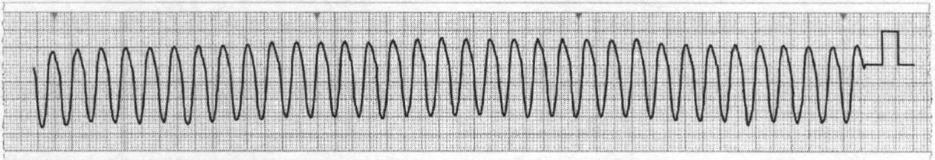
Fig. Ventricular tachycardia without a pulse

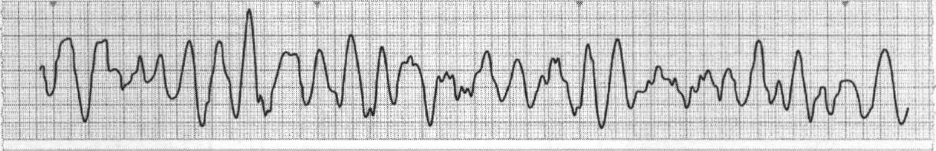
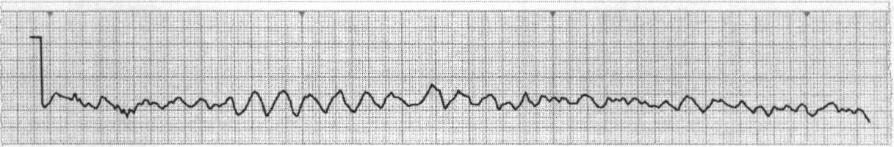
Fig. Ventricular fibrillation

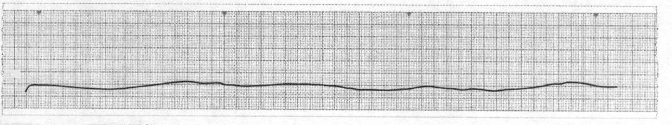
Fig. Asystole

It should be remembered that ventricular fibrillation / ventricular tachycardia without pulse is a defibrilated circulatory arrest, whereas electrical activity without pulse / asystole is a circulatory arrest which does not require electrical defibrillation.

Step D: Drug therapy
Routes of drugs administration
Two major routes for drug administration are recommended:
- intravenous, in the central or peripheral vein. The best option is the central vein – superior vena cava (catheterization through the subclavian and internal jugular vein), as it provides delivery of the medication injected into the central circulation. To achieve the same effect when introduced into the peripheral vein, medications should be diluted in 20 ml of saline or sterile water and the limb must be lifted for some time;
- Intraosseous - this way of administration of drugs provides adequate plasma concentration over time compared to the introduction of drugs into the central vein. The use of mechanical devices for intraosseous administration of drugs provides the ease and accessibility of this way of administration.
Pharmacological support of resuscitation
- Adrenaline
a). in the case of electrical activity without pulse / asystole - 1 mg every 3-5 minutes intravenously;
b). in the case of ventricular fibrillation / ventricular tachycardia without pulse - 1 mg after the third ineffective discharge of electrical defibrillation, then in persistent ventricular fibrillation - every 3-5 minutes intravenously throughout the period of cardiopulmonary reanimation;
- Amiodarone – antiarrhythmic first-line treatment for ventricular fibrillation/pulseless ventricular tachycardia (VF/PVT) refractory to electric pulse therapy. It is used after 3 charges at the initial dose of 300 mg (diluted in 20 ml of saline or 5 % glucose). If necessary, the dose of 150 mg may be repeated after the fifth ineffective discharge.
- Lidocaine – an initial dose of 100 mg (1–1.5 mg/kg), if necessary, additional bolus of 50 mg can be given (a total dose should not exceed 3 mg/kg within 1 h) – as an alternative in case of absence of amiodarone. It should not be used as a supplement to amiodarone.
- Sodium bicarbonate – routine used during CPR or after the restoration of spontaneous circulation is not recommended. Sodium bicarbonate is recommended at a dose of 50 mmol (50 ml – 8.4 % solution) in case of cardiac arrest associated with hyperkalemia or tricyclic antidepressant overdose.
- Calcium chloride – a dose of 10 ml 10 % solution in case of hyperkalemia, hypocalcemia, an overdose of calcium channel blockers.

Step F: Defibrillation
The principle of defibrillation is the depolarization of the critical mass of the myocardium, which contributes to the restoration of sinus rhythm by a natural rhythm driver, because the cells of the sin-auricular pacemaker are the first cells of the myocardium capable of depolarizing spontaneously.
If ventricular fibrillation/ ventricular tachycardia without a pulse is determined on a cardiac monitor (defibrillator), one discharge should be performed.
After the discharge, no rhythm or pulse should be evaluated, and chest compression and other components of cardiopulmonary resuscitation should be started immediately and should be performed during 2 min. And only then we should check the rhythm of the ECG and in the case of restoration of sinus rhythm - we should determine its hemodynamic efficiency for the presence of a pulse on the carotid artery. Even if defibrillation is effective and the sinus rhythm according to the ECG recovers, very rarely immediately after defibrillation, it is hemodynamically effective. It means it can generate a pulse and blood circulation. Usually you should perform chest compressions longer than one minute to restore self-circulation (pulse). It should be emphasized that in case of restoration of hemodynamically effective rhythm, additional chest compression will not lead to re-development of ventricular fibrillation. On the contrary, in the case of recovery of only organized bioelectric activity of the heart according to the ECG, but hemodynamically ineffective, termination of chest compression will inevitably lead to ventricular refibrillation.
The above facts are the reasoning for conducting of chest compression for 2 min after applying a defibrillation discharge and subsequent ECG rhythm assessment. In the case of restoration of sinus rhythm, the evaluation of carotid pulsation should be done.
A delay between the defibrillation discharge and the start of chest compression should not be more thean 10 seconds.
If after the discharge the ventricular fibrillation / ventricular tachycardia without puls persists, defibrillation with higher energy re-discharge should be performed and followed by cardiopulmonary resuscitation for 2 min.
The initial energy level for biphasic defibrillators should be 150-200 J (or lower depending on the defibrillator model) followed by an escalation of energy up to 360 J at repeated discharges. Beginning energy for mono-phase defibrillators, which are not recommended now, should be 360 J, as for all subsequent discharges.
Shock – CPR for 2 min – Assessment of rhythm / pulse- Shock – CPR for 2 min- Assessment of rhythm / pulse-…
Efficacy and safety of electrical defibrillation depends on several factors, among which the following should be mentioned:
1) Proper positioning of electrodes on the chest. Since only 4 % of the trans­thoracic current passes through the heart, and 96 % – through the rest of the chest structures, it is very important to locate them adequately. One electrode is installed at the right edge of the sternum under the clavicle, the second laterally to the left nipple on the midaxillary line. If a patient has a pacemaker, defibrillator electrodes should be kept at a distance at least 8 cm from it.
2) Chest resistance, or transthoracic resistance, is an important factor affecting the effectiveness of defibrillation because it explains the difference between the current energy set on the scale of the apparatus and the effect on the patient. For example, if there are factors that significantly increase transthoracic resistance during resuscitation, it is likely that with a 360 J of energy of defibrillator on the scale, its real value for the myocardium may be at best 10% (30-40 J). Therefore, it is unacceptable to use dry electrodes, because this greatly reduces the defibrillation efficiency and causes skin burns.
In order to reduce the electrical resistance of the chest, it is imperative to use a special defibrillator gel or gaskets moistened with hypertonic solution. In the extreme, the surface of the defibrillator can be simply moistened with any conductive solution (isotonic sodium chloride solution, water).
Thick hair on the chest causes poor contact of the electrodes with the patient's skin and increases resistance, reducing the effectiveness of the discharge and increases the risk of burns. Therefore, it is advisable to shave the area of the chest before the electrodes are applied.
Compliance of safety rules during performing of this procedure is very important. During defibrillation none of the rescuer-participants should touch the skin of the patient and/or his bed.
It is recommended now to use adhesive (self-adhesive) electrodes instead of standard electrodes, because they have been shown to be comfortable to use, release hands and allow minimization of pauses before defibrillation.
Features of CPR and conditions of its termination
The probability of a favorable outcome of CPR when PEA/asystole (as in refractory VF/VT) can be enhanced only if there are potentially reversible causes of treatable diseases. They are presented in the form of a universal algorithm “4 H – 4 T”.
"Four H -Four T" algorithm
Hypoxia, hypovolemia, hyper / hypokalemia, hypothermia / hyperthermia
Tension, tamponade of heart, thrombosis (coronary or pulmonary), toxic overdose.
Cardiopulmonary resuscitation should be performed as long as the ECG retains ventricular fibrillation, as this preserves minimal metabolism in the myocardium, providing the potential for restoration of independent circulation.
In case of cardiac arrest by the mechanism of electrical activity without pulse / asystole, in the absence of a potentially reversible cause (according to the algorithm "four H-four T" - cardiopulmonary resuscitation is carried out within 30 minutes and in case of its inefficiency is stopped.
Cardiopulmonary resuscitation for more than 30 minutes is carried out in cases of hypothermia, drowning in ice water and overdose of drugs.
The time of CPR termination is registered as time of death.

STAGE III: PROLONGED LIFE SUPPORT
Step G: Assessment of the condition (identifying the causes of cardiac arrest and its elimination) and the possibility of complete rescue of the patient taking into account the degree of damage of the central nervous system
The first task after spontaneous circulation restoration is to assess the patient’s condition. It can be formally divided into two subtasks: 1) determining the cause of clinical death (to prevent repeated episodes of cardiac arrest, each of which worsens the prognosis of full patient recovery), 2) defining the severi­ty of homeostasis disorders in general and of cerebral functions in particular (to determine the intensive therapeutic approach).
Aid stages include mental restoration, intensive therapy aimed at correcting the disturbed functions of other organs and systems.
Step H. Restoration of normal thinking.
Step I. Intensive care aimed at correcting of impaired functions of other organs and systems

Postresuscitation disease
This specific pathological condition develops due to ischemia caused by the general lesion of blood circulation, and reperfusion after successful resuscitation. It is characterized by severe disorders of different homeostasis components along with an impaired integrative function of the CNS. Postresuscitation disease possesses its own particular etiology – an inseparable combination of global ischemia with reperfusion and reoxygenation. Reoxygenation and reperfusion after cardiac arrest not only cope with the consequences of primary pathological effects, but also cause a cascade of new lesions. It is important that the cause of these changes is not global ischemia itself, but rather its combination with reoxygenation and reperfusion.
Posthypoxic encephalopathy is the most common variant of the course of post-resuscitation disease. It manifests in one or another degree in all patients who have suffered a cardiac arrest, which is understood as a brain lesion existing in the pre-gradual development after short-acting anoxia. Posthypoxic encephalopathy is defined as a set of neurological and psychiatric disorders in all stages of the post-axial period.
Postresuscitative therapy
A) Extracerebral homeostasis. After restoration of spontaneous circulation postresuscitative therapy should be based on the following principles:
1). Early optimization of hemodynamics. Due to the failure of autoregulation of the cerebral circulation in the post-operative period, the level of cerebral perfusion pressure (CPP) becomes dependent on the level of average blood pressure (ABP):
CPP = ABP - intracranial pressure.
Therefore, it is very important to maintain normotension, so systolic blood pressure should be more than 100 mm Hg, average blood pressure should be 70-90 mm Hg. As hypertension as well as hypertension, should be corrected.
2). Oxygenation: arterial hyperoxia should be excluded, the level of FiO₂ should provide meanig of SaO₂ in 94-98%, since it is shown that the artificial ventilation of the lungs with FiO₂ 1.0 in the first hour of post-resuscitation period is associated with adverse neurological consequences due to the creation of additional oxidat ive stress;
3). Maintaining of normal levels of PaO₂ (normoxemia) and PaCO₂ (normocapnia). Whereas vasoconstriction, which is caused by hyperventilation, as well as hypoventilation, which causes an increase of intracranial pressure, leads to an increase of cerebral ischemia;
4). Maintaining of blood glucose level <10 mmol / l, for the preventing of the development of the hypoglycemia.
5). Control of the convulsive activity - convulsive syndrome and especially early epistatus are predictors of adverse outcome. The introduction of benzodiazepines, fentoin, valproate is recommended. In the case of constant epiactivity - propofol or sodium thiopental.

B) Intracerebral homeostasis.
Currently, therapeutic hypothermia is considered to be the most effective method of neuroprotective brain protection. The current ERC 2015 recommendations have made changes to the target of temperature management of patients who have registered cardiac arrest. All patients who have suffered a cardiac arrest and are unconscious should be provided with maintenance of body temperature in the range of 32-36° C. Emphasis is placed on maintaining of primarily normothermia and preventing of hyperthermia, especially in the first 24 hours of the post-resuscitation period. In this case, the use of hypothermia induction technologies up to 32-34° C for 12-24 h may be effective in many patients who have suffered a cardiac arrest.

